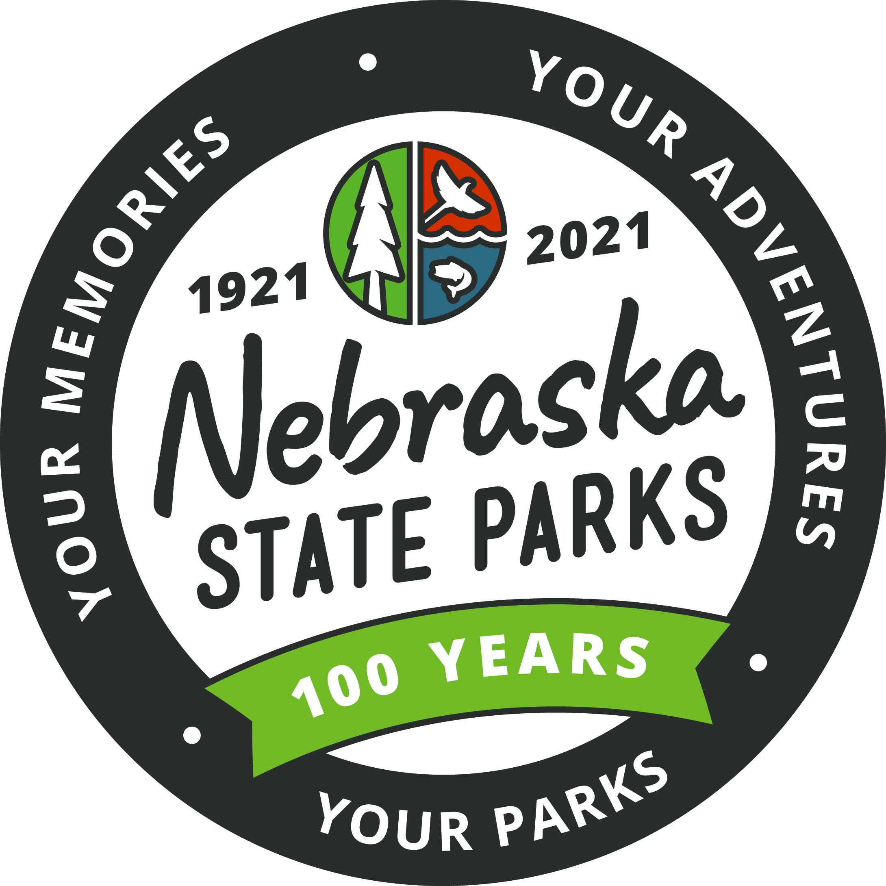
Nebraska State Parks Centennial Lesson Plan
Activity Title:
Build a Park

Grade Level:
Upper Elementary

Method:
During this activity students will design a new state park (either on paper or a 3D model). Students can also design a brochure, to tell others about their new park.

Materials:
Paper (graph paper might be helpful)
Markers/crayons

Optional supplies:
Clay
Glue
Tape
scissors and other art supplies
Small toys such as plastic animals, people, buildings, trees, etc.
Natural materials collected outside such as leaves, sticks, rocks, etc.
Recycled materials:
egg/milk cartons
Cardboard
Lids
small boxes
String
rubber bands
Foil
Magazines
Cereal boxes

State Standards:
SS 3.4.2.a; SS 4.3.1.a

Objective:
Students will 1) develop an understanding and appreciation of Nebraska state parks, 2) understand the resources it takes to manage and maintain a park.

Background:
Nebraska State Parks, State Historical Parks and State Recreation areas represent Nebraska’s beauty, wildlife, history and people. They also represent our heritage. They protect fragile or unique ecosystems, wildlife habitat, human-made or natural structures, waterways, and riparian zones. Each park has one or more of these features, which is why it is protected. These areas are set aside so that the best of Nebraska’s scenery, history, nature, and wilderness is protected for future generations. The park superintendent manages our parks for recreation, education, and preservation. For recreation, parks must offer certain facilities and activities, such as campgrounds, hiking trails, overlooks, lodges and cabins. Educational efforts by the park service include visitor centers, museums, naturalist programs, and informational pamphlets, maps, and guides. Furthermore, staff must be able to answer questions on a variety of subjects, including interpreting the park’s features, problems facing the park, and the dangers within the park. Finally, for preservation, law enforcement officers must set and enforce rules. These rules have two purposes: to protect the visitor and protect the park’s resources. Rules ensure that everyone has a safe and enjoyable visit, and that resources are protected for future visitors to enjoy.

When a State Park is built, there are a lot of factors that go into the design. What feature is the area highlighting? Is it historic, a unique natural resource or a special place for family time? Engineers not only have to think about how the park is laid out, but also what it takes to manage and maintain the state park.

Step-By-Step Instructions:

- Read the shortened mission statement: Nebraska Game and Parks Commission strives to provide safe and diverse recreational and educational outdoor opportunities for all to enjoy. They also help to build lifelong memories that preserve outdoor family traditions. Creating opportunities that promote a sense of wonder, excitement, curiosity and exploration is also important to NGPC.

- Discuss the purpose of parks, their characteristics, and the different features they protect (i.e. ecosystem, natural or human-made structures, etc.). Ask if anyone has been to a state park and, if so, which one? What did they see? What was the park protecting? Discuss the reasons for creating a state park. Who owns them?

- Explain that the students will create their own state park. Have them think about what they would like to see/protect in their park. Is it possible to conserve resources unimpaired while still providing for their public enjoyment? Brainstorm how park managers can protect park resources and provide for people to visit parks without damaging the resources.

- Have students work as individuals or in teams to create their own state parks. Students should carefully study the literature and other material they collected from real parks. They can simply draw their park on butcher paper, create a three dimensional park on cardboard using natural and recycled material, or come up with other ideas.

- Start by having the students design the natural and/or cultural features of their park. Have them use their imagination when designing their park resources. For instance, sticks can be used for a forest, blue cellophane can make a river, rocks can become a butte range, and small toys from home can represent wildlife or historic features.

- Have them think about what park visitors will need when they visit the park and what might be needed to protect the natural and cultural resources of the park. Again, let their imaginations guide them in developing trails, motels, visitor centers, museums, restaurants, viewpoints, signs, barriers, entrance stations, souvenir and book shops, medical facilities, maintenance facilities, staff housing and offices, campgrounds, transportation facilities (roads, parking lots, busses, etc.), etc.

- Students will need to design a brochure highlighting the features of the park and what it has to offer. Include a map, safety messages, park rules, fees charged (if any), tours and education programs offered. Draw pictures of the park or use cut outs from old magazines.

- Students can then become the park superintendent, taking the class on a “park tour” and explaining the features and services provided. Encourage students to ask the presenters thoughtful questions.

- After everyone has had a chance to present their park, the class should discuss what they learned. Here are some discussion ideas:
Park Purpose:
What was their purpose?
What was their favorite resource and/or park and why?
Park Characteristics:
What would they change about their park?
Did each park have enough facilities to accommodate visitors?
Were educational programs offered?
How much would it cost to manage their park?
Should an entrance fee be charged?
Who should or shouldn’t have to pay?
What should be done with the trash and sewage generated by people
living in, working in, and visiting the park?
Park Conservation (what they protect):
Did all the parks have resources important enough to be protected?
How were the natural and cultural resources protected?

Focus Questions:
- How did you choose the five rules to follow?
- What was the coolest part (best feature) of your park? Why?

Resources:
Nebraska State Parks Guide

Activity adapted from NatureBridge and Create a Park, Everglades National Park.

